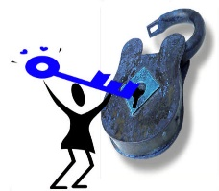
Square Dance Minnesota Diploma

Let it be known to all that the dancer named below holds the

key to a fun-filled activity that will unlock years of fun,

fellowship, and fitness. Square dancing is great fun with

friendly people and is guaranteed to put a smile on your face.

This certifies that
Click here to enter name.

has completed the mainstream calls and is granted

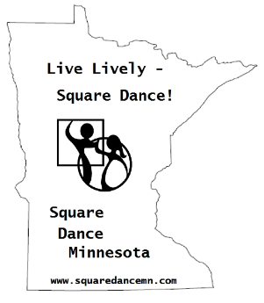
all the privileges of the square dancing community.
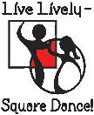

Dated this Choose a date. day of Choose a month., Choose a year.

Click here to enter caller, instructor, or organization official name.

